# Brainstorming – Idea Generation – Prioritization

|  |  |
| --- | --- |
| **Date** | **30 JUNE 2025** |
| **Team ID** | **LTVIP2025TMID47465** |
| **Project Name** | **Cosmetic Insights: Navigating Cosmetics Trends and Consumer Insights with Tableau** |
| **Maximum Marks** | **4 Marks** |

## Ideation Phase

**Brainstorm & Idea Prioritization Template**

Brainstorming is essential for data-driven exploration in the cosmetics industry. It provides a collaborative environment where team members generate creative ideas, focusing on consumer behavior, product trends, and strategic insights using Tableau for data visualization.  
  
This template guides your team in unlocking insights even when working remotely.

## Step-1: Team Gathering, Collaboration, and Selection of Problem Statement

**Problem Statement**:

How can we use Tableau dashboards to analyze and visualize large-scale cosmetic industry data—highlighting consumer trends, product popularity, and market segmentation—to empower decision-making for cosmetic brands?

## Step-2: Brainstorming, Idea Listing, and Grouping

|  |  |  |  |  |  |  |  |  |  |  |  |  |  |
| --- | --- | --- | --- | --- | --- | --- | --- | --- | --- | --- | --- | --- | --- |
| |  |  | | --- | --- | | **Categories** | **Ideas** | | Consumer Behavior | - Track buying habits by age and gender - Preferences in skincare vs. makeup | | Product Trends | - Identify top-selling cosmetics - Analyze trends over time and by region | | Market Insights | - Highlight emerging markets - Compare product performance by sales channels | | Visualization Goals | - Build dashboards using bar, pie, heatmaps in Tableau | | Sentiment Analysis | - Analyze customer reviews - Use word clouds to represent top concerns | |  |

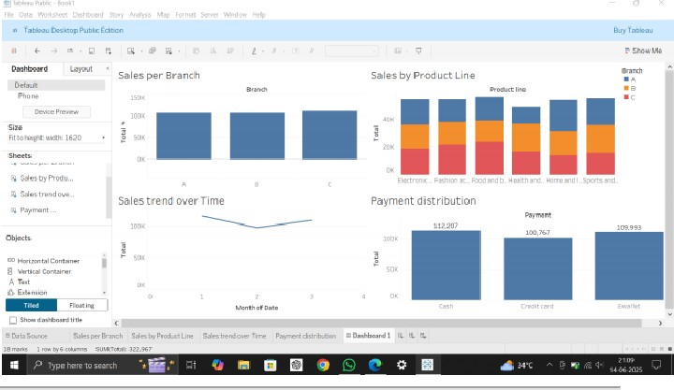

**Demographic pie chart showing consumer segments :**

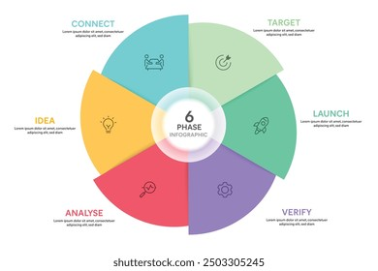

## Step-3: Idea Prioritization

|  |  |  |  |
| --- | --- | --- | --- |
| **Idea** | **Impact** | **Feasibility** | **Priority Level** |
| Dashboard of top product trends | High | High | ✅ Top Priority |
| Customer demographic segmentation | High | Medium | ✅ Top Priority |
| Sentiment analysis using reviews | Medium | Medium | 🔄 Consider |
| Predictive analytics for emerging trends | High | Low | ⚠ Future Scope |
| Market comparison | Medium | High | 🔄 Consider |

**Impact vs Flexibility matrix:**



